# How to send sms in android

We can send sms in android via intent. You need to write only 4 lines of code the send sms in android.

//Getting intent and PendingIntent instance

Intent intent=**new** Intent(getApplicationContext(),MainActivity.**class**);

PendingIntent pi=PendingIntent.getActivity(getApplicationContext(), 0, intent,0);

//Get the SmsManager instance and call the sendTextMessage method to send message

SmsManager sms=SmsManager.getDefault();

sms.sendTextMessage("8802177690", **null**, "hello javatpoint", pi,**null**);

Example of sending sms in android

**activity_main.xml**

Drag the 2 edittexts, 2 textviews and 1 button from the pallete, now the activity_main.xml file will like this:

*File: activity_main.xml*

**<RelativeLayout** xmlns:androclass="http://schemas.android.com/apk/res/android"

    xmlns:tools="http://schemas.android.com/tools"

    android:layout_width="match_parent"

    android:layout_height="match_parent"

    tools:context=".MainActivity" **>**

**<EditText**

        android:id="@+id/editText1"

        android:layout_width="wrap_content"

        android:layout_height="wrap_content"

        android:layout_alignParentRight="true"

        android:layout_alignParentTop="true"

        android:layout_marginRight="20dp"

        android:ems="10" **/>**

**<EditText**

        android:id="@+id/editText2"

        android:layout_width="wrap_content"

        android:layout_height="wrap_content"

        android:layout_alignLeft="@+id/editText1"

        android:layout_below="@+id/editText1"

        android:layout_marginTop="26dp"

        android:ems="10"

        android:inputType="textMultiLine" **/>**

**<TextView**

        android:id="@+id/textView1"

        android:layout_width="wrap_content"

        android:layout_height="wrap_content"

        android:layout_alignBaseline="@+id/editText1"

        android:layout_alignBottom="@+id/editText1"

        android:layout_toLeftOf="@+id/editText1"

        android:text="Mobile No:" **/>**

**<TextView**

        android:id="@+id/textView2"

        android:layout_width="wrap_content"

        android:layout_height="wrap_content"

        android:layout_alignBaseline="@+id/editText2"

        android:layout_alignBottom="@+id/editText2"

        android:layout_alignLeft="@+id/textView1"

        android:text="Message:" **/>**

**<Button**

        android:id="@+id/button1"

        android:layout_width="wrap_content"

        android:layout_height="wrap_content"

        android:layout_alignLeft="@+id/editText2"

        android:layout_below="@+id/editText2"

        android:layout_marginLeft="34dp"

        android:layout_marginTop="48dp"

        android:text="Send SMS" **/>**

**</RelativeLayout>**

**Write the permission code in Android-Manifest.xml file**

You need to write SEND_SMS permission as given below:

<uses-permission android:name="android.permission.SEND_SMS"/>

*File: Android-Manifest.xml*

<?xml version="1.0" encoding="utf-8"?>

<manifest

xmlns:androclass="http://schemas.android.com/apk/res/android"

**package**="com.example.sendsms"

    android:versionCode="1"

    android:versionName="1.0" >

    <uses-sdk

        android:minSdkVersion="8"

        android:targetSdkVersion="16" />

    <uses-permission android:name="android.permission.SEND_SMS"/>

    <uses-permission android:name="android.permission.RECEIVE_SMS"/>

    <application

        android:allowBackup="true"

        android:icon="@drawable/ic_launcher"

        android:label="@string/app_name"

        android:theme="@style/AppTheme" >

        <activity

            android:name="com.example.sendsms.MainActivity"

            android:label="@string/app_name" >

            <intent-filter>

                <action android:name="android.intent.action.MAIN" />

                <category android:name="android.intent.category.LAUNCHER" />

            </intent-filter>

        </activity>

    </application>

</manifest>

**Activity class**

Let's write the code to make the phone call via intent.

*File: MainActivity.java*

**package** com.example.sendsms;

**import** android.os.Bundle;

**import** android.app.Activity;

**import** android.app.PendingIntent;

**import** android.content.Intent;

**import** android.telephony.SmsManager;

**import** android.view.Menu;

**import** android.view.View;

**import** android.view.View.OnClickListener;

**import** android.widget.Button;

**import** android.widget.EditText;

**import** android.widget.Toast;

**public** **class** MainActivity **extends** Activity {

    EditText mobileno,message;

    Button sendsms;

    @Override

**protected** **void** onCreate(Bundle savedInstanceState) {

**super**.onCreate(savedInstanceState);

        setContentView(R.layout.activity_main);

        mobileno=(EditText)findViewById(R.id.editText1);

        message=(EditText)findViewById(R.id.editText2);

        sendsms=(Button)findViewById(R.id.button1);

    //Performing action on button click

        sendsms.setOnClickListener(**new** OnClickListener() {

            @Override

**public** **void** onClick(View arg0) {

                String no=mobileno.getText().toString();

          String msg=message.getText().toString();

                //Getting intent and PendingIntent instance

                Intent intent=**new** Intent(getApplicationContext(),MainActivity.**class**);

                PendingIntent pi=PendingIntent.getActivity(getApplicationContext(), 0, intent,0);

                //Get the SmsManager instance and call the sendTextMessage method to send message

                SmsManager sms=SmsManager.getDefault();

                sms.sendTextMessage(no, **null**, msg, pi,**null**);

                Toast.makeText(getApplicationContext(), "Message Sent successfully!",

                    Toast.LENGTH_LONG).show();

            }

        });

    }

    @Override

**public** **boolean** onCreateOptionsMenu(Menu menu) {

        // Inflate the menu; this adds items to the action bar if it is present.

        getMenuInflater().inflate(R.menu.activity_main, menu);

**return** **true**;

    }

}

***Install and Run the apk file on the Real Device (e.g. Mobile) to send the sms.***

**Output:**

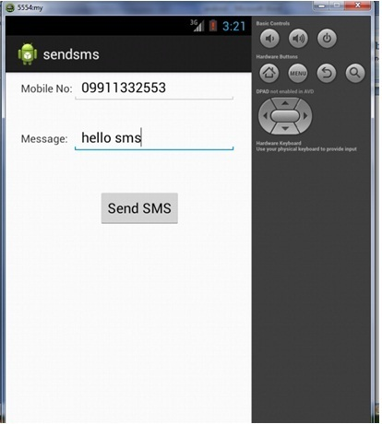  
  
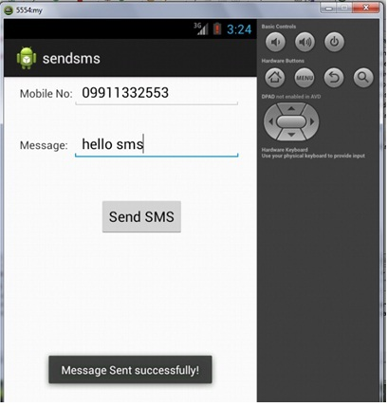

Prepared By: Prof. Kamlesh A. Meshram